Tecnológico de Monterrey
Campus Estado de México
Departamento de TI y Computación
Profesora. Patricia Chávez
Redes 1
Problemas

- Selecciona la(s) opción(es) correctas.

1 – Assume that 4 bits have been borrowed. Identify the subnet addresses (choose 3)
a 192.168.14.8
192.168.14. 0000 1000 -> HOST
b 192.168.14.16
192.168.14. 0001 0000 -> Subnet
c 192.168.14.24
192.168.14. 0001 1000 -> HOST
d 192.168.14.32
192.168.14. 0100 0000 -> Subnet
e 192.168.14.148
192.168.14. 1001 0100 -> HOST
f 192.168.14.208
192.168.14. 1101 0000 -> Subnet

2 – Assuming a subnet mask of 255.255.224.0, which of the following would be a valid host address? (choose 3)

Mask = 255.255. 1110 0000. 0 -> 1111 1111 . 1111 1111. 1110 0000. 0000 0000

a 124.78.103.0
124.78. 0110 0111.0

0110 0111
1110 0000 0110 0000 != 0110 0111 X
--------------
0110 0000
b 125.67.32.0

125.67. 0010 0000.0

0010 0000
1110 0000 0010 0000 = 0010 0000 ✓
--------------
0010 0000

c 125.78.160.0

125.78. 1010 0000.0

1010 0000
1110 0000 1010 0000 = 1010 0000 ✓
--------------
1010 0000

d 126.78.48.0

126.78. 0011 0000.0

0011 0000
1110 0000 0010 0000 != 0011 0000 X
--------------
0010 0000

e 176.55.96.0

176.55. 0110 0000.0

0110 0000
1110 0000 0110 0000 = 0110 0000 ✓
--------------
0110 0000

f 186.211.100.0

186.211. 0110 0100.0

0110 0100
1110 0000 0110 0000 = 0110 0100 X
--------------
0110 0000

3 – Which of the following are private IP addresses? ( choose 3)

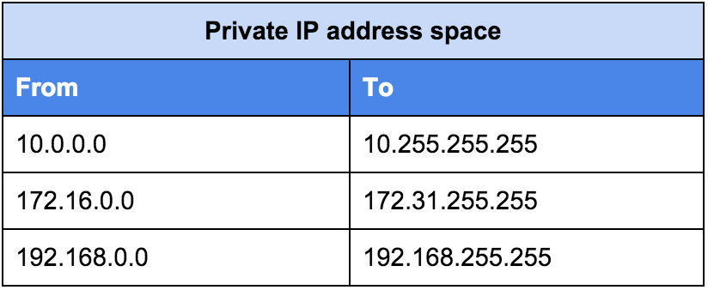

a 172.168.33.1 – PUBLIC IP ADDRESS
b 10.35.66.70 – PRIVATE IP ADDRESS
c 192.168.99.5 – PRIVATE IP ADDRESS
d 172.18.88.90 – PRIVATE IP ADDRESS
e 192.169.77.89 – PUBLIC IP ADDRESS
f 127.33.55.16 – LOOP-BACK ADDRESS

4 – The router reads each bit to determine the class of an address. Which of the following binary numbers would the router identify as a public class A address? (choose 3)

Class A -> 0000 0000 – 0111 1111 , ( 1 – 127 )

a 0000 1010. 1010 1100. 1100 1100. 0000 0111
10. 172. 204. 7
b 0001 1111. 1111 0011. 1111 1111. 0011 1011
31. 243. 255. 59
c 0101 1101. 1110 0001. 1100 1100. 1101 1011
93. 225. 204. 219
d 1000 0000. 1111 1000. 1100 0111. 1111 0011
128. 248. 199. 243
e 0001 0111. 1101 1011. 1100 0001. 1100 1100
23. 219. 193. 204

5 – What is the maximum number of subnets that can be assigned to networks when using the address 172.16.0.0 with a subnet mask of 255.255.240.0 ?

240 -> 1111 0000 = 4 Subnet bits … 2⁴ → 16 Subnets

a 16
b 32
c 30
d 14
e this is an invalid subnet mask for the Network

6 – Which network mask should you place on a class C address to accommodate a user requirement of two sub networks with a maximum of 35 hosts on each network?

Class C -> 1100 0000 – 1101 1111, (192 – 223) NNNH
2 Subnets
35 MAX Hosts

1111 1111. 1111 1111. 1111 1111. 1110 0000 → 224

A 255.255.255.192
B 255.255.255.224
C 255.255.255.240
D 255.255.255.248

7 – How many valid host IP addresses are available on the following network/subnetwork? 198.197.196.16/30 → Number of Bits in the Subnetwork Address
1100 0110. 1100 0101. 1100 0101. 0001 0000 → 2² = 4 Hosts – 2 Hosts (Network and Broadcast) = 2 Usable Hosts
a 2
b 30
c 254
d 16,382
e 65,534

8- Given an IP address of 172.16.2.160 and a subnet mask of 255.255.255.192, to which subnet does the host belong?
Host = 1010 1100. 0001 0000. 0000 0001. 1010 0000
Mask = 1111 1111. 1111 1111. 1111 1111. 1100 0000
------------------------------------------------------------------------------------------
Subnetwork = 1010 1100. 0001 0000. 0000 0001. 1000 0000 -> 128
A 172.16.2.32
B 172.16.2.64
C 172.16.2.96
D 172.16.2.128
E 172.16.2.192

9 – Given the following IP address from the class B address range:
172.35.21.12 Class B → 1000 0000 – 1011 1111, (128 – 191) NNHH

Your network plan requires no more than 126 hosts on a subnet that includes this address. When you configure the IP address in Cisco IOS software, which value should you use as the subnet mask?

MAX HOSTS = 126 -> 2⁷ = 128 Hosts – 2 Hosts (Network and Broadcast)
Subnet = 1010 1100. 0010 0011. 0001 0101. 0000 1100
Mask = 1111 1111. 1111 1111. 1111 1111. 1000 0000

A 255.255.0.0
B 255.255.128.0
C 255.255.255.128
D 255.255.255.252

10 - You are given an ip adress 132.15.136.2/18 what subnet is the host ip on ?
IP Address = 1000 0100. 0000 1111. 1000 1000. 0000 0010
Mask = 1111 1111. 1111 1111. 1100 0000. 0000 0000 (18 Subnetwork bits)
---------------------------------------------------------------------------------
Subnetwork = 1000 0100. 0000 1111. 1000 0000. 0000 0000
= 132. 15. 136. 0
A 132.15.136.0
B 132.15.128.0
C 132.15.192.0
D 132.15.64.0

11- In order to have 5 subnets and 17 hosts on each subnet, how many bits of subnetting
will you use on the class B address 162.13.0.0/16 ?
IP Address = 1010 0010. 0000 1101. 0000 0000. 0000 0000
MIN Subnets Required → 2³ = 8 - 2 (Network and Broadcast) = 6 Subnets
Mask = 1111 1111. 1111 1111. 1110 0000. 0000 0000 (3 Subneting Bits provided)
Mask = 255.255.224.0
A 255.255.128.0
B 255.255.224.0
C 255.255.240.0
D 255.255.248.0

- Obtén las direcciones de cada subred de la dirección 15.0.0.0/22 y completa lo que se te pide.

IP Address = 0000 1111. 0000 0000. 0000 0000. 0000 0000
Mask = 1111 1111. 1111 1111. 1111 1100. 0000 0000 (22 Subnet Bits) = 255.255.252.0
----------------------------------------------------------------------------------------------------
Subnet = 0000 1111. 0000 0000. 0000 0000. 0000 0000 = 15.0.0.0
Broadcast = 0000 1111. 0000 0000. 0000 0011. 1111 1111 = 15.0.3.255

Máscara de subred |  | Bits de subred |  | Máximo de subredes utilizables | Máximo de hosts utilizables | Dirección de la red |  | Dirección de broadcast de la red
255.255.252.0 |  | 22 |  | 2⁶ -2 = 62 Subnets | 2¹⁰ – 2 = 1022  Usable Hosts | 15.0.0.0 |  | 15.0.3.255
# Subred | Dirección de la subred |  | Rango |  |  |  | Dirección de broadcast
5 | 15.0.20.0 |  | 15.0.20.1 – 15.0.23.254 |  |  |  | 15.0.23.255
13 | 15.0.52.0 |  | 15.0.52.1 – 15.0.55.254 |  |  |  | 15.0.55.255
29 | 15.0.116.0 |  | 15.0.116.1 – 15.0.119.254 |  |  |  | 15.0.119.255
63 | 15.0.252.0 |  | 15.0.252.1 – 15.0.255.254 |  |  |  | 15.0.255.255
127 | N/A |  | N/A |  |  |  | N/A

